Data Transmission Series

User Manual

Model : RS001R
RS485 Data Repeater

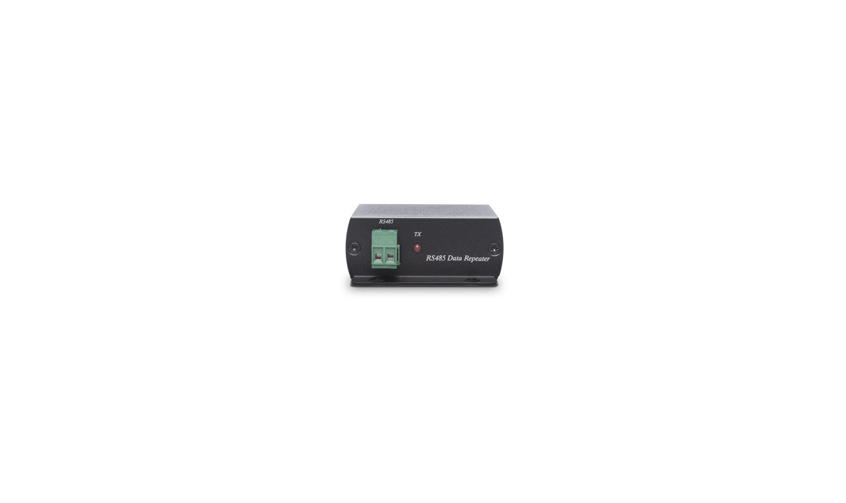

Introduction

RS001 is a data converter that converts RS232 to RS485 signal without power required and also carrys the signal to 1200M away...

Features

- Converts RS232 to RS485 signal.
- Supports up to 115200 bps baud rate.
- Signal extension up to 1200M.
- No power required..

Installation View
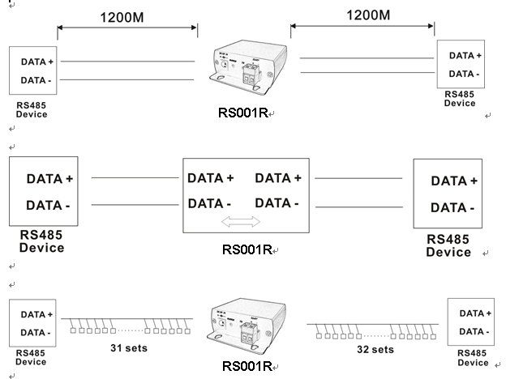

Panel View
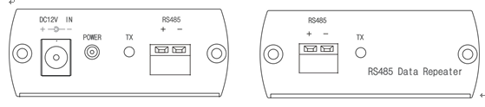

Note: When using RS001R the responding RS-485 device must wait for the auto transmit enable to revert back to the receive state. If the responding RS-485 device transmits a packet back less than one byte time after the end of the packet, then there is possibility of a data collision on the RS-485 interface.

Specification

ITEM NO. | RS001R
Support
Standard | RS485
Max. Baud Rate | 115200 bps
Max. Transmission Distance | 1200M for each RS001R added
Ports & Interfaces
Data Input | 1 x Terminal Block
Data Output | 1 x Terminal Block (1V p-p, 75Ω)
Power Interface | 1 x DC Jack
Power
DC Power Voltage | +10 to 20V
Power Supply | DC 12V 500mA
Power Consumption | 100mA (Max)
Ambient Temperature
Operation | 0 to 55℃
Storage | -20 to 85℃
Humidity | Up to 95%
Physical Characteristics
Dimensions | 67 x 87 x 27mm
Weight | 130g

